ENTRY FORM KASPICHAN CUP 2024
COUNTRY
ADRES
CLUB
E-MAIL
COMPETITOR

№ | Name and Surname | Address | FAI ID | FAI License No. | Shirt No
1
2
3
4
5
6
7
8
9
10
11
Size of T-Shirt: M L XL XXL
CATEGORIES
Pl. | S4A | S6A | S7 |  | S8 E/P | S9A |  | S3A
1
2
3
4
5
6
7
8
9
10
11
LUNCH ON THE FIELD |  |  |  | No. of persons
BANQUET |  |  |  | No. of persons

End date for sending the entry form is 15. April 2024!!!

Date: Signature:

KASPICHAN CUP 2024 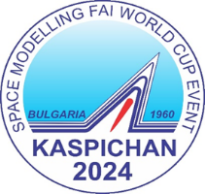

Motors:
For all those who did not manage to make requests to the respective manufacturer before the release of the Kaspichan Cup bulletin, the organizer will provide engines under the following conditions: Sending a request for quantities necessary only for participation in the Kaspichan Cup by March 31, 2024.
After this date, the organizer does not undertake to provide engines.
Payment for the engines will be at the manufacturer's prices upon receipt of the engines in Kaspichan by the manufacturer or his representative.

Yambol Jet
pieces | S4 | S6 | S8 | S9 | S3
details

Ultra Energy Link
pieces | S4 | S6 | S8 | S9 | S3
details

Date: Signature:

